11/06/24, 15:56 glifo.pdf

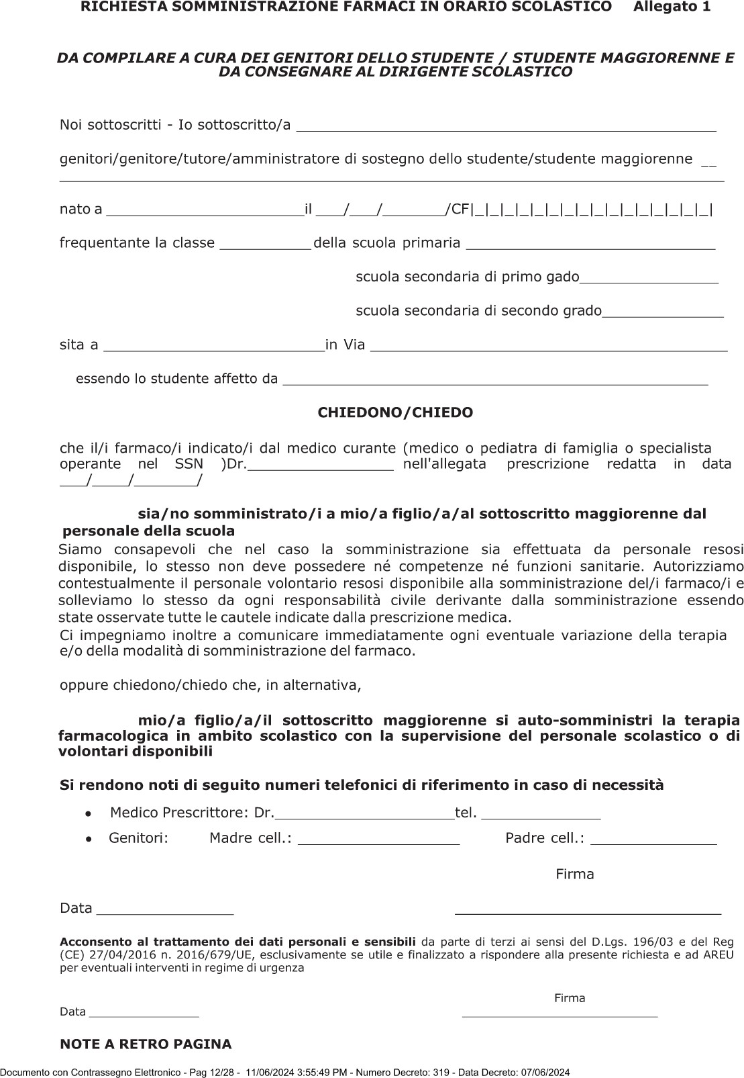

https://protocollo.ats-brescia.it/InteractiveDashboard/Reserved/Card/Detail 12/28